**Module 3: Docker Part 1**

**Assignment – 1**

1. Created an EC2 instance

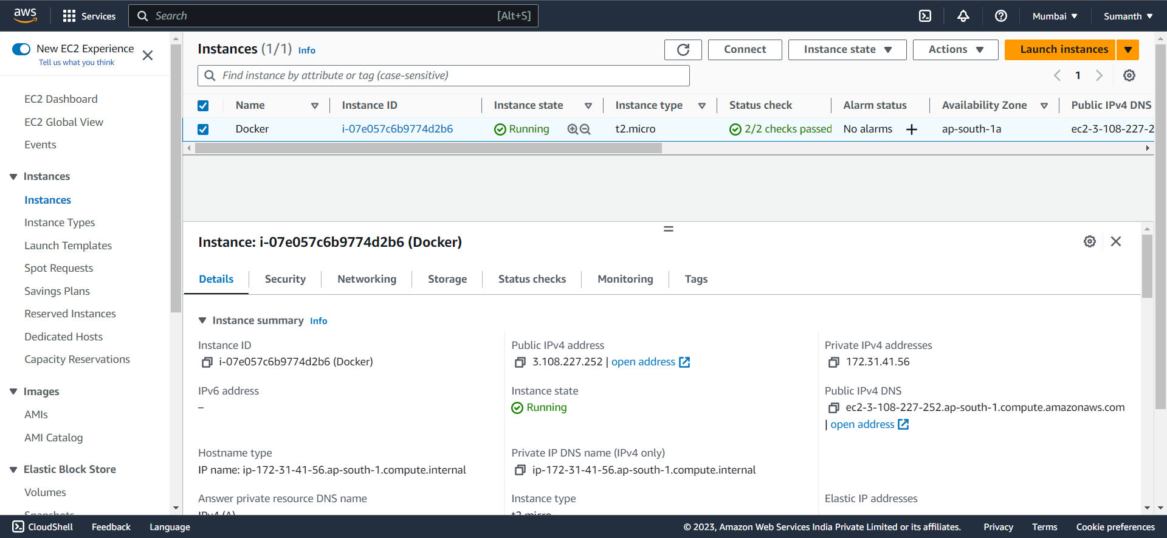

1. Installed Docker

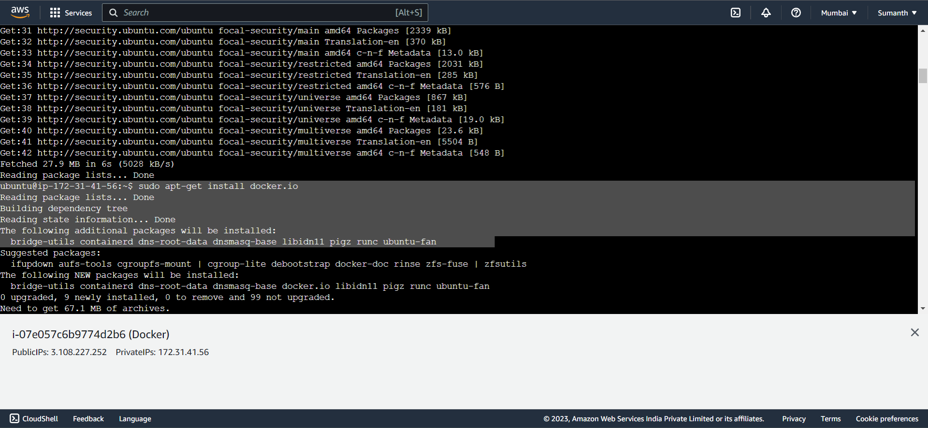

1. Pulled Ubuntu container

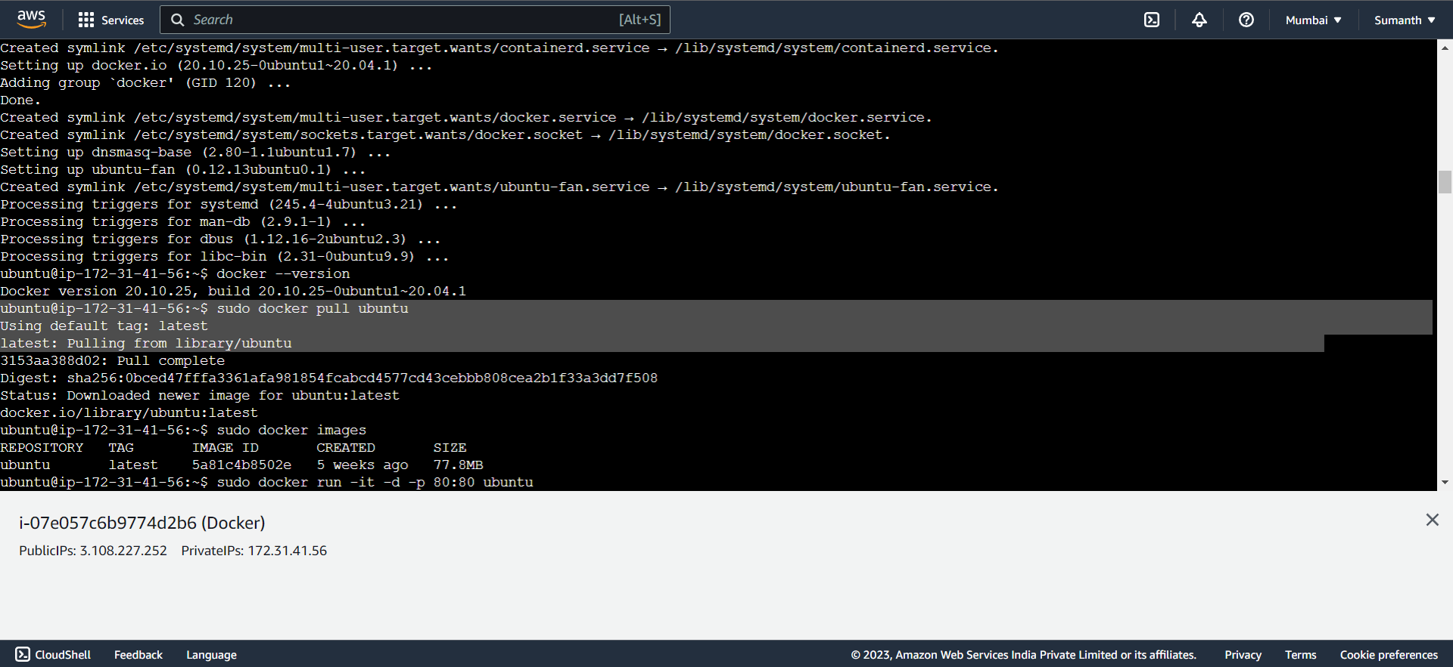

1. Ran container on map port 80 on the local

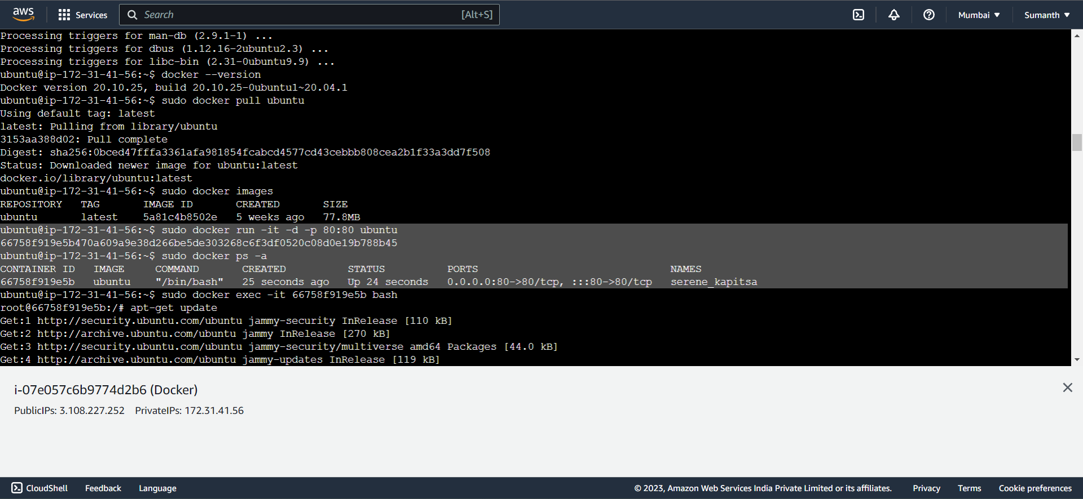

1. Installed Apache 2 on the container

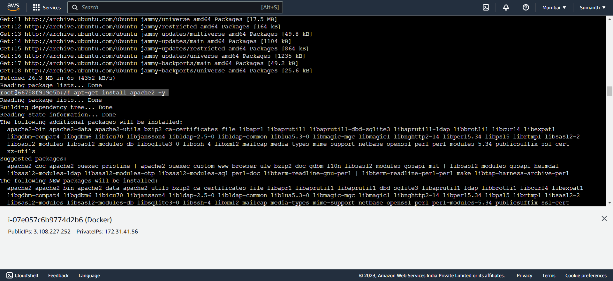

1. Able to access the Apache page on my browser

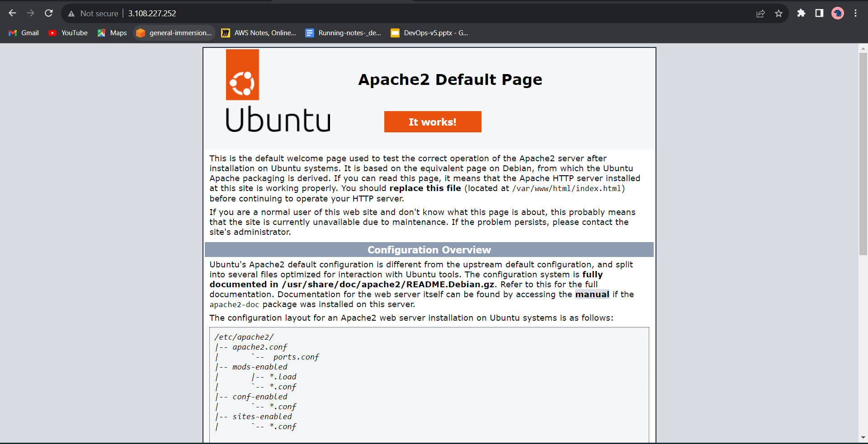

1. Commands used for this assignment

1 sudo apt-get update

2 sudo apt-get install docker.io

3 docker --version

4 sudo docker pull ubuntu

5 sudo docker images

6 sudo docker run -it -d -p 80:80 ubuntu

7 sudo docker ps -a

8 sudo docker exec -it 66758f919e5b bash

1 apt-get update

2 apt-get install apache2 -y

3 service apache2 status

4 service apache2 start

5 service apache2 status